Restricción por IP
Abajo ves la advertencia en rojo: sin IP restringida, si se habilita cualquier permiso que no sea lectura, la key se eliminará automáticamente.
Para la euru_research_key de lectura pura, sin IP es aceptable por ahora. Pero registra esto como deuda técnica para el Automation Engineer.

Haz esto ahora — en este orden
1. Copia y guarda ambas claves en tu gestor de contraseñas o lugar seguro AHORA
- Clave API: QLBfzI1RZdRlmWnGZ8D2LG3pDJfQlMfCkpKhptm6nmKJhWDNrC0iHYvUuv1rIsuK
- Clave Secreta: la que empieza con 7aMnafk0X58gau3d...
Si cierras esta pantalla sin guardar la clave secreta, se pierde para siempre.

21:53
STOP. Same as before — save both keys NOW.
euru_userdata_key credentials are visible. This is the only time Binance shows the secret key.
Save immediately:
- API Key: Mv7zJ8rCYEvwLwqPW99DFTFYeHsY8fWwWCX06P1kLlBGuA1xDmYaIro6yInkbILz
- Secret Key: CkfcNHH6ZeW9XPtHe6gGw50chfKNjKigXODzTGHwQl6UH1ZRNDNqva5IpCfGBwFo

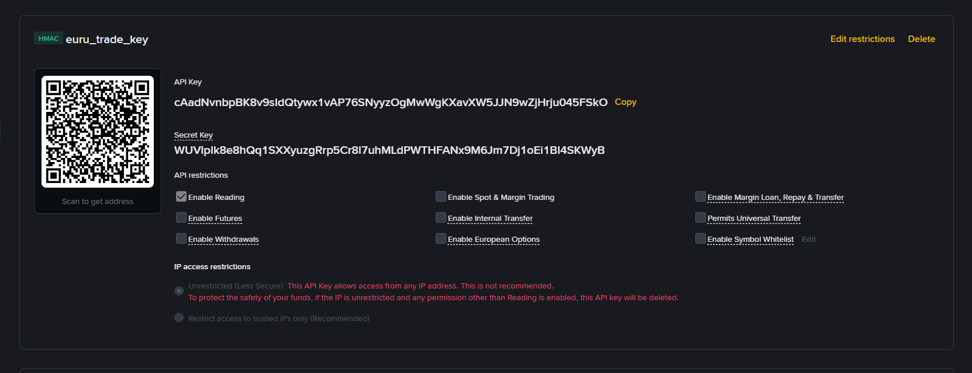

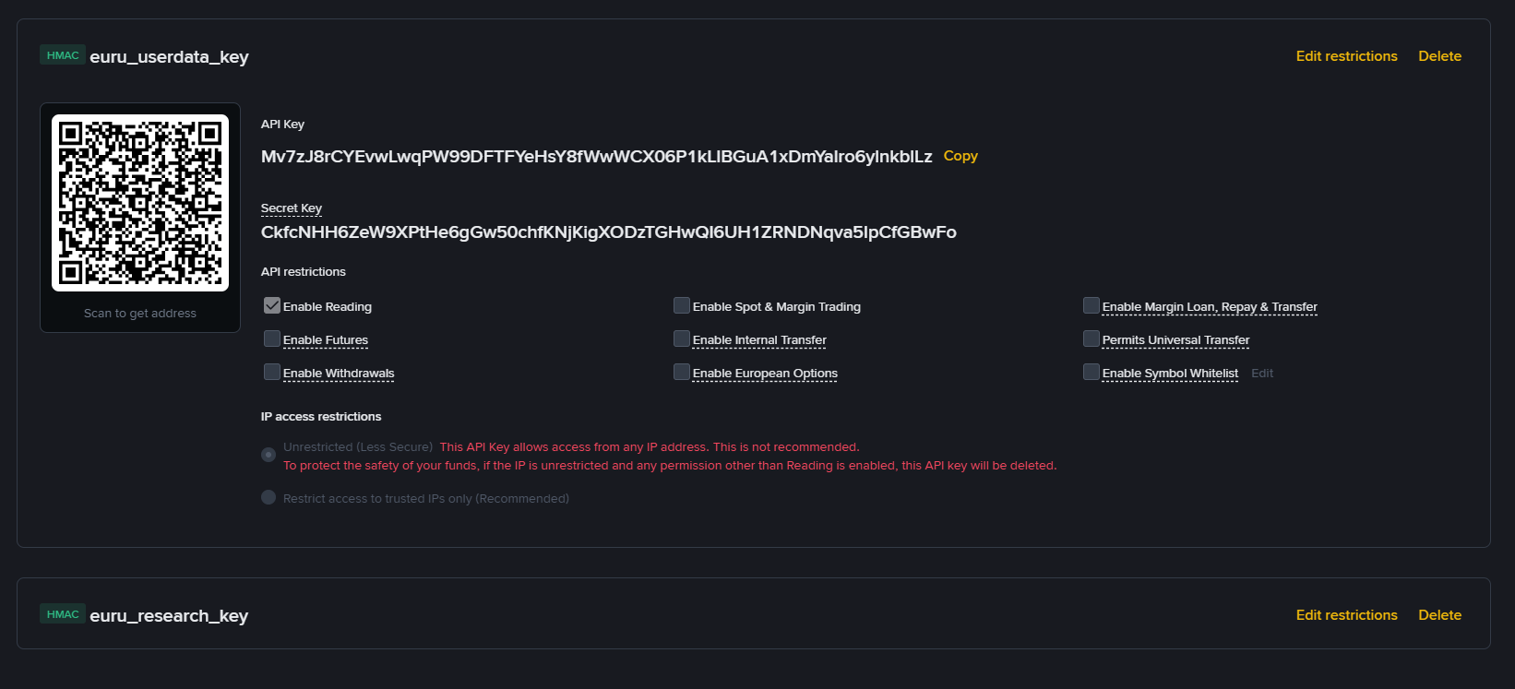

# API_KEYS_E_PERMISSOES.md

## Last updated: 2026-03-27

---

## Key 1 — euru_research_key
- Type: HMAC
- Purpose: Market data reading, Scout agent feed
- Permissions: Enable Reading only
- IP restriction: Unrestricted (to be reviewed by Automation Engineer)
- Owner: Risk/Product Owner
- Status: ACTIVE

---

## Key 2 — euru_userdata_key
- Type: HMAC
- Purpose: Account monitoring, order history, balance
- Permissions: Enable Reading only
- IP restriction: Unrestricted (to be reviewed by Automation Engineer)
- Owner: Automation Engineer
- Status: ACTIVE

---

## Key 3 — euru_trade_key
- Type: HMAC
- Purpose: Future execution (reserved)
- Permissions: Enable Reading only — NO trading enabled
- IP restriction: Unrestricted
- Owner: Risk/Product Owner + Automation Engineer approval required
- Status: EXECUTION_BLOCKED
- Note: Dormant until formal phase transition approval

---

## Security rules
- Secret keys stored outside EURU_OS folder
- No plain text secrets in any project file
- Trading permissions require approval from both humans
- IP whitelist to be configured by Automation Engineer

---

## Pending (Automation Engineer — Week 1)
- Configure IP whitelist for all 3 keys
- Set up .env.example with placeholder structure
- Validate connectivity in READ_ONLY mode

# DEMO_TRADING.md

## Status: CONFIRMED
## Date: 2026-03-27

## Environment
- URL: demo.binance.com
- Futures Demo: ACTIVE
- Spot Demo: available via tab
- Virtual balance: 5,000 USDT (Futures)
- Positions: 0 — clean

## Region
- Spain (ES) — Demo Trading accessible

## Observations
- "Back to Live" button clearly visible
- Environment visually distinct from live
- No orders placed — navigation only

## Next action
- Do NOT place any orders
- Use this environment for observation only
- Automation Engineer to validate API connectivity
to demo environment in Week 1

# Responsibilities — Euru OS
# Date: 2026-03-27

## Human 1 — Risk/Product Owner
Operator: Andre

Responsible for:
- Strategic vision and mission
- Risk rules and limits
- Phase transitions (READ_ONLY → SIMULATE → EXECUTE)
- Freezing assets, agents or strategies
- Approving critical changes
- Weekly governance review

Must NOT:
- Make infrastructure decisions impulsively
- Approve phase transitions in the same session proposed
- Skip the 24-hour rule for critical changes

## Human 2 — Automation Engineer
Operator: Andre (solo — same person, separate context)

Responsible for:
- Folder structure and file organization
- API keys, secrets and connectivity
- Logs and snapshots
- Technical stability
- READ_ONLY enforcement at infrastructure level
- Incident response

Must NOT:
- Enable execution without Risk/Product Owner approval
- Store secrets in plain text
- Accept "works more or less" as stable

## Solo Operation Rules
- Strategic and technical decisions must happen
in separate sessions
- Any critical change requires 24-hour waiting period
between proposal and execution
- Weekly self-review mandatory — minimum 1 hour
- Documentation written as if an external auditor
will read it

# Change Governance — Euru OS
# Date: 2026-03-27

## Core principle
Every relevant change must be:
- proposed in writing
- waited on (minimum time per type)
- approved or rejected
- recorded in CHANGELOG.md

---

## Change Type 1 — Light Operational
Examples:
- prompt text adjustment
- field name correction
- scorecard clarity improvement

Waiting period: none
Approval: Risk/Product Owner (self)
Record: CHANGELOG.md

---

## Change Type 2 — Moderate Structural
Examples:
- agent logic change
- watchlist asset swap
- daily routine adjustment
- output schema modification

Waiting period: 24 hours
Approval: both roles reviewed separately
Record: CHANGELOG.md + DECISOES_ESTRATEGICAS.md

---

## Change Type 3 — Critical Strategic
Examples:
- READ_ONLY → SIMULATE transition
- enabling execution
- risk rule modification
- creating or removing an agent
- activating hedge
- secrets policy change

Waiting period: 48 hours minimum
Approval: formal written checklist completed
Record: CHANGELOG.md + DECISOES_ESTRATEGICAS.md
+ dedicated decision file

---

## The 24-hour rule
Any change that affects risk, agents or system
mode cannot be proposed and executed in the
same session. Period.

---

## Change proposal template

### Title
Short name of the change

### Type
light / moderate / critical

### Reason
Why is this change being proposed?

### Expected impact
What improves or changes?

### Risk
What could go wrong?

### Waiting period
Start date / approval date

### Status
- [ ] approved
- [ ] rejected
- [ ] pending

---

## Golden rule
If the change affects risk, system mode
or execution — it never happens without
a completed written checklist.

# Unified Status Standard — Euru OS
# Date: 2026-03-27

## Purpose
Prevent agents from using different language
to express the same thing.
One concept = one word. Always.

---

## Structural States
NO_TRADE — no observable setup
WATCHLIST — asset under observation
SETUP — potential trade identified

## Flow States
CONFIRMS — flow confirms the hypothesis
CONTRADICTS — flow contradicts the hypothesis
INCONCLUSIVE — flow gives no clear signal

## Risk States
APPROVE — risk parameters acceptable
REJECT — risk parameters unacceptable
REVIEW — insufficient data to decide

## Execution States
EXECUTION_ALLOWED — all gates cleared
EXECUTION_BLOCKED — at least one gate closed
MANUAL_REVIEW_REQUIRED — human decision needed

## Infrastructure States
HEALTHY — system operating normally
DEGRADED — partial functionality loss
CRITICAL — system must enter READ_ONLY

## News Severity
LOW — no operational impact
MEDIUM — monitor, no action required
HIGH — reassess open hypotheses
CRITICAL — suspend all new entries

## System Modes
READ_ONLY — observe, record, learn. No orders.
SIMULATE — simulate decisions, no real capital.
EXECUTE — real orders. Future phase only.

---

## Conflict resolution hierarchy
When agent outputs conflict, this order prevails:

1. DevOps Guardião — infrastructure problem wins
2. Execution Orchestrator — operational block wins
3. Quant/Risk Officer — bad risk wins
4. News Sentinel — critical news wins
5. Flow Analyst — flow contradiction wins
6. Scout — structure alone never wins

---

## Translation rule
A beautiful structure does not override a broken rule.
A strong narrative does not override bad risk.
A partial confirmation does not override a block.

# Week 1 Schedule — Euru OS
# Date: 2026-03-27
# Operator: Solo — Andre

## Week objective
Get Euru operating in controlled READ_ONLY mode
with minimum daily routine, organized documentation,
all agents defined and first integrated test completed.

## Expected result at end of week
- EURU_OS/ folder complete and organized
- All 7 agent briefings and prompts saved
- Binance account validated — DONE ✅
- 2FA active — DONE ✅
- Demo Trading confirmed — DONE ✅
- 3 API keys created — DONE ✅
- Journal functional with at least 1 entry
- Watchlist active with BTCUSDT and ETHUSDT
- First integrated test completed
- All governance documents approved — IN PROGRESS

---

## Day 1 — Foundation
Status: COMPLETE ✅
Delivered:
- Binance security configured
- 3 API keys created with separation of powers
- Demo Trading confirmed
- Keys saved securely

---

## Day 2 — Architecture and Governance
Status: IN PROGRESS 🔄
Role: Risk/Product Owner
Tasks:
- Approve RESPONSABILIDADES_HUMANOS.md ✅
- Approve GOVERNANCA_DE_MUDANCAS.md ✅
- Approve PADRAO_UNIFICADO_DE_STATUS.md ✅
- Approve CRONOGRAMA_SEMANA_1.md (this document)
- Approve CHECKLIST_VALIDACAO_READ_ONLY.md

---

## Day 3 — Technical Organization
Role: Automation Engineer
Tasks:
- Organize EURU_OS/ folder structure
- Create .env.example with key placeholders
- Save all 7 agent briefings and prompts
- Define log and snapshot structure
- Document API architecture in
API_KEYS_E_PERMISSOES.md

---

## Day 4 — Market Observation
Role: Risk/Product Owner
Tasks:
- Open watchlist_core.csv
- First reading of BTCUSDT and ETHUSDT
- Run Scout, Flow Analyst, News Sentinel manually
- Fill first SCORECARD_DIARIO.md
- First entry in TEMPLATE_JOURNAL.csv

---

## Day 5 — Integrated Test + Self-Review
Role: Both
Tasks:
- Run full integrated test: BTCUSDT
- Scout → Flow → News → Quant →
Orchestrator → Journal
- Identify inconsistencies between agents
- Fill CHECKLIST_VALIDACAO_READ_ONLY.md
- Record week result in DECISOES_ESTRATEGICAS.md

---

## Solo operation rules this week
- Strategic and technical sessions stay separate
- 24-hour rule applies to all moderate changes
- Every agent output g

# READ_ONLY Validation Checklist — Euru OS
# Date: 2026-03-27

## Purpose
Confirm that Euru is genuinely ready to operate
in disciplined observation mode before any
further phase is considered.

---

## Block 1 — Governance
- [ ] Mission approved
- [ ] Constitution saved
- [ ] Regras-Mãe saved
- [ ] Responsibilities defined
- [ ] Change governance approved
- [ ] Unified status standard approved
- [ ] 24-hour rule understood and committed to

## Block 2 — Structure
- [ ] EURU_OS/ folder organized
- [ ] All 7 agent briefings saved
- [ ] All 7 agent prompts saved
- [ ] All 7 agent output formats saved
- [ ] SOP_DIARIO.md saved
- [ ] SOP_SEMANAL.md saved

## Block 3 — Binance and Security
- [ ] Binance account validated
- [ ] 2FA fully configured
- [ ] Demo Trading confirmed
- [ ] 3 API keys created with correct permissions
- [ ] euru_research_key — reading only
- [ ] euru_userdata_key — reading only
- [ ] euru_trade_key — EXECUTION_BLOCKED
- [ ] Secrets stored outside EURU_OS/
- [ ] API_KEYS_E_PERMISSOES.md documented

## Block 4 — Data and Operation
- [ ] watchlist_core.csv created
- [ ] BTCUSDT added to watchlist
- [ ] ETHUSDT added to watchlist
- [ ] TEMPLATE_JOURNAL.csv created
- [ ] At least 1 journal entry recorded
- [ ] SCORECARD_DIARIO.md created and filled
- [ ] Daily routine defined and understood

## Block 5 — Integrated Test
- [ ] Full pipeline tested: Scout → Flow →
News → Quant → Orchestrator → Journal
- [ ] BTCUSDT used as test case
- [ ] Agent conflicts identified and noted
- [ ] Adjustments recorded in CHANGELOG.md

## Block 6 — Solo Operation
- [ ] 24-hour rule applied at least once
- [ ] Strategic and technical sessions
kept separate
- [ ] All decisions recorded as if
external auditor will read them

---

## Final result
Mark one:

- [ ] READ_ONLY APPROVED
→ Proceed to Week 2 in evolved READ_ONLY

- [ ] READ_ONLY APPROVED WITH ADJUSTMENTS
→ Continue READ_ONLY, fix flagged items first

- [ ] READ_ONLY INCONCLUSIVE
→ Do not advance, repeat parts of Week 1

- [ ] READ_ONLY FAILED
→ Freeze expansion, reorganize foundations

---

## Week 1 strengths
(fill at end of Day 5)

## Week 1 weaknesses
(fill at end of Day 5)

## Priority for Week 2
(fill at end of Day 5)

